Correlation GUI User Guide

Corrui 0.4

Index
Correlation GUI User Guide 1
Index 2
1. Introduction 3
2. Requirements 4
3. Getting Started 4
4. Import Data… 5
5. Process Data 7
5.1. Fading experiment process options 9
5.2. Eye movement experiment process options 11
6. Plotting Session Data (“canned” plots) 12
Advanced plot options 14
7. Aggregate Sessions 15
8. Plotting Session Variables 16

Introduction
The correlation GUI provides an interface to import, process, and view the results of correlation-type analyses of data collected in microsaccade experiments. The data generally consists of eye movements and button press events, and the correlation is performed between these data types.

A given experimental run is denoted as a “session” in the GUI. Usually a single session corresponds to data collected from a single experimental session, but sessions can be combined, as is the case when it makes sense to treat several sessions as one continuous session. Sessions consist of variables, such as the eye movement raw data, button press timestamps, intermediate data, and the results -- statistics and measures of correlation calculated from the raw data.

The GUI (shown in Figure 1) consists of 4 main sections: database location, Variable Description, Session Controls and Variable Controls. The database location is a computer file directory: all imported data for a given experiment is stored in files in a single directory. The Variable Description panel displays text that describes a variable selected in the Variable Controls panel, or the description of a given session file (not yet implemented). The Session Controls area contains a list of session types, a list of the sessions of the selected type, and buttons that perform actions that modify or display plots related to the entire session. The Variable Controls consists of a list of variables for the selected session(s) and buttons to plot these raw, intermediate, and result data.

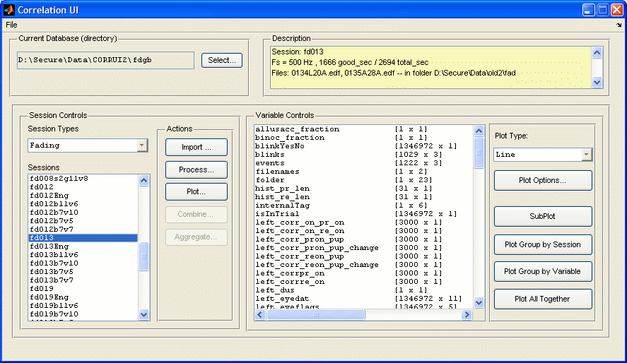
Figure 1 GUI main window with data loaded

The user does not generally need to be too aware of the file structure of the database. The GUI will scan a directory for MAT files matching a specific signature to find the sessions in a given directory. In general, for the current implementation, the file names for a given session begin with that session, then have an underscore ‘_’, then the variable name, then ‘.mat’.

The GUI can be used to process different session types, what means different experiments or different ways to process the same experiment. Also, the data can come from different source that use different format. The GUI will convert the data from the available formats to a common format to work with it.

Requirements
The main requirements are Windows XP and Matlab 7, with the statistics and signal processing toolboxes. In addition, many matlab files are in source control that are necessary to run corrui, so please get the latest code.

Another major requirement is to have the SR Research, Inc. Eyelink utilities installed on the computer. In particular, the ‘edf2asc.exe’ utility MUST be in the Path variable. After locating the .exe, you can make sure it is on the Path by clicking “Start” / ”Settings” / “System” / ”Advanced” / ”Environment Variables”. In that dialog, choose the “PATH” variable in the list and click “Edit”. Add the location of the “edf2asc.exe” file to the end of the Path string, and click “OK”.

Getting Started
Though Figure 1 shows a fully-loaded GUI with processed data, when you first run the program, all of the panels will be blank as in Figure 2:
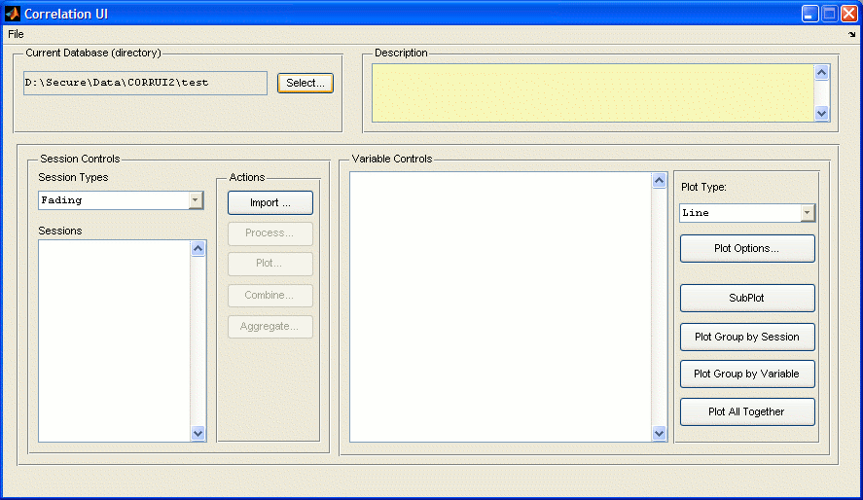
Figure 2 Main window as it appears after starting when the database directory contains no data

To load data, you can click the “Select…” button and select a directory you know has data that was processed with the Correlation GUI, or select a directory into which you want to put data from an experiment. This does NOT have to be the directory in which the raw data files are stored.

Import Data…
Before importing any data the type of session should be chosen in the drop-down box.
To get data into the database, click the “Import …” button which will bring up a different dialog depending on the possible data sources for the type of session selected.
For example, for the Fading sessions there is only one possible data source at this moment. This is the EDF file that comes from Eyelink and both eye movement data and timestamps of events like trial start/stop and button presses to report visibility/invisibility of the stimulus.
The dialog will allow selecting multiple files, in which case one session will be created in the database from the selected data files. The program will “concatenate” the data in the order the files are selected, but generally the order is not important.
First and optionally, a dialog with the possible data sources will appear. For example, for the eye movement experiment there are two data sources, LAB files and EDF files.
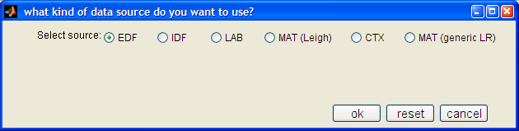
Figure 3 Import Data, select files

In the next dialog two main things have to be specified, the files that are going to be imported and the name of the sessions that will be created. To select the files just click the button next to the text box. The name of the session should start by a prefix depending of the type of session. This prefix is added to the session name always. Then there are other minor options that will depend on the data source that is being imported.

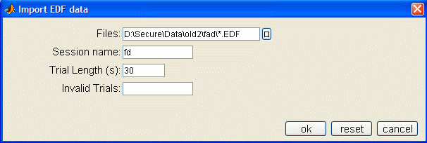
Figure 4 Import Data, select files

Now the process of importing the data will start. Data files are generally large, and take several minutes to be parsed into Matlab. Progress is displayed at the Matlab command line, as well as in a small waitbar dialog, that will update its progress indicator at the end of each file processed. Once the import is finished, the waitbar will disappear.

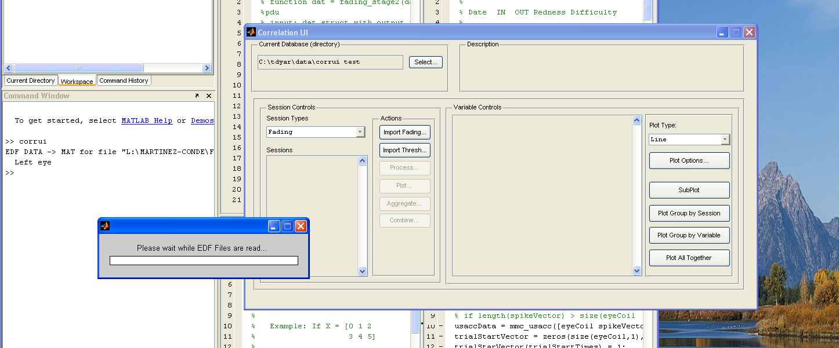
Figure 5 Import Data, progress shown at Matlab command line, and in waitbar

Then when you click on the session name in the Sessions list on the left side of the main window, some variables will be displayed in the Variables list on the right, as in Figure 6. These variables contain the raw data that comes from the files; however, some process could have been made to accommodate the format of the different data sources to a common format for the experiment.

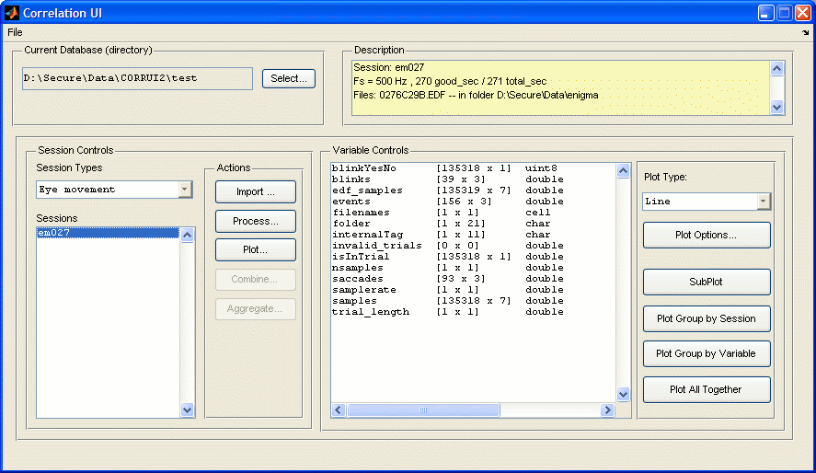
Figure 6 Import done, raw data variables show up in list on right
Also, when we select a session we can see in the Description area some information about the session, like the sampling rate, the total length of the session and the files that were used to create the session.

Process Data
The objective of the GUI is to perform some correlations and display the results, so the next step is to “process” the imported data. There are 2 stages of processing: stage 1 for pre-processing and stage 2 for calculating correlations. The first stage calculates the microsaccades from the raw eye movement data in the “samples” variable, and parses out the trials and subject responses from the “buttons” raw data variable. Whereas stage 1 is a fixed amount of processing dependent only on the size of the raw data in the session(s), the second stage can be configured to perform as few as 1 and as many as the entire range of correlations, which can take several hours for a single data session. It is for this reason that the pre-processing and correlation stages are separated.
The first stage will be the same for all the experiment while the stage2 will vary completely according to the experiment.

To start processing data, select the sessions you want to process in the “Sessions” list on the left of the GUI, and click the “Process…” button. Another window will appear, the “Process Sessions Parameters” dialog shown in Figure 7, where various options are configured. Here you can change the name of the sessions, which will place the results of processing into a new session of the name entered. This is useful for comparing the effects of different Stage 1 options such as the amount of smoothing.

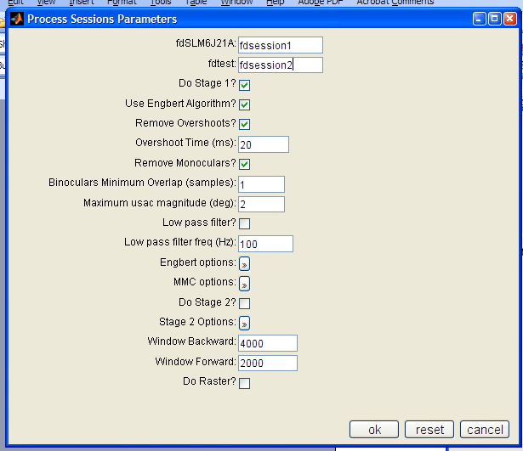
Figure 7 Process Sessions Parameters dialog box
Here is a list of the Process Options (in this case for a fading experiment) and a short description of their function:

- Session names are the first edit boxes in which the user can override the session names. One box for each selected session will appear so you can enter a new name for each of them.
- “Do Stage 1?”: Yes/No to indicate whether trial and microsaccade pre-processing should be performed
- Use Engbert Algorithm: If selected the Engbert algorithm will be used to detect microsaccades, otherwhise the MMC algorithm will be used.
- Remove Overshoots: If two microsaccades are detected very close to each other the second one will be removed. This avoid the detection of overshoots as microsaccades.
- Overshoot Time: Minimum time in milliseconds that needs to be in between microsaccades.
- Remove Monoculars: Monocular microsaccades will be removed if selected
- Binoculars Minimum Overlap: Binocular microsaccades will be defined as the ones with at least this number of samples of overlap between the two eyes.
- Maximum usac magnitude: Limit in magnitude that determine what are microsaccades and what are saccades.
- Low Pass filter: Apply’s a Butterworth low pass filter to the eye movement data before detecting the microsaccades.
- Low Pass filter freq: Frecuency cut for the low pass filter.
- Engbert options
  - Velocity factor: number of times the standard deviation of the velocity is the threshold used.
  - Minimum duration: minimum duration for a microsaccade in samples.
- MMC options
  - “Smoothing Method”: Select Boxcar, Savitsky-Golay, or None smoothing algorithms
  - “Smoothing Parameter 1”: for Boxcar the size of the smoothing window in the x-direction; for Savitsky-Golay, the order of the filter (order of polynomial fit)
  - “Smoothing Parameter 1”: for Boxcar the size of the smoothing window in the y-direction; for Savitsky-Golay, the order length in milliseconds of the smoothing window
- Do Stage 2: Yes/No to indicate whether correlation processing should be performed
- Stage 2 Options: Select which correlations to perform (below)
- Window Backward: Number of milliseconds before zero to calculate correlations
- Window Forward: Number of milliseconds after zero to calculate correlations
- Do Raster: do a raster for the correlations selected.

The options on the “Process Sessions Parameters” dialog are primarily for stage 1, except for the “Window Backward”, “Window Forward” and “Do raster” which does apply to all of the correlations. The Stage 2 options are set by clicking the “Stage 2 Options” button. The “Stage 2 Options” dialog box, shown in Figure 8, provides check boxes for a large number of correlations. In general, correlations that end in “Percept” take much longer to calculate. This is because these correlations take into account every millisecond the stimulus was reported visible/invisible, not just the transitions between the visibility states.

Fading experiment process options
As we have seen for the fading experiment we can select which of the possible correlations are going to be calculated in the stage 2.
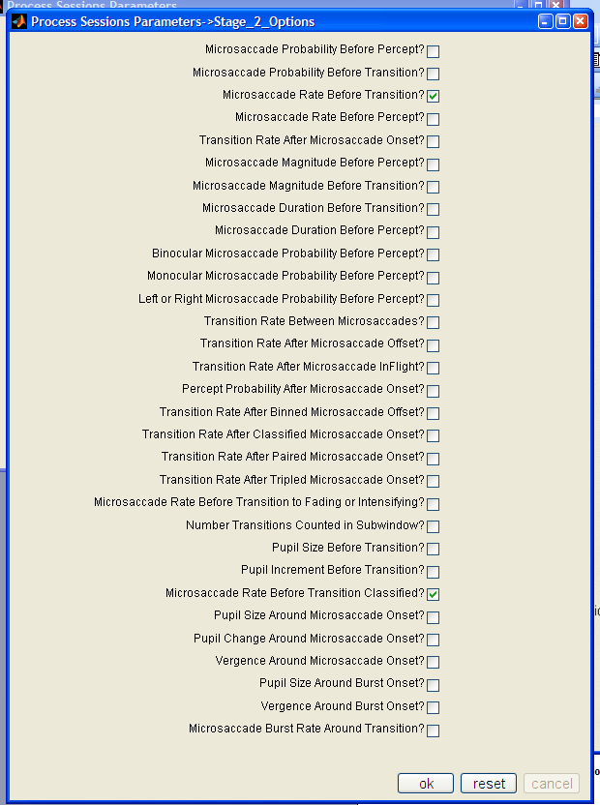
Figure 8 Stage 2 Options is a series of "check boxes" denoting whether or not to calculate a class of correlations

The currently implemented correlations include the following examples:
- “Microsaccade Probability Before Percept”: Probability, at each millisecond before each visibility/invisibility percept, that a microsaccade is “in flight”
- “Microsaccade Probability Before Transition”: Probability, at each millisecond before the transition to visibility/invisibility, that a microsaccade is “in flight”
- “Microsaccade Rate Before Transition/Percept”: Rate of microsaccades before visibility/invisibility percepts/transitions
- “Transition Rate After Microsaccade Onset”: Rate of visibility/invisibility transitions after a microsaccade starts

NOTE: For “Microsaccade Probability Before Transition” correlation, the Binocular, Monocular and “Left or Right” microsaccade calculations are performed automatically, whereas for the “Microsaccade Probability Before Percept” correlation, these other microsaccade types have to be specified manually.

Eye movement experiment process options
The processing options for this experiment will be almost the same than in the previous case. Since in this experiment there are no correlations involved, the window backward and forward are not shown in the dialog.
At the moment there is only one possible item to select in the stage 2 for this experiment, Square Wave Jerks. If this option is checked an algorithm for detecting Square-Wave Jerks will be executed.

Once you have chosen the Stage 1 options and the Stage 2 correlations you want calculated, click “OK” on the “Process Sessions Parameters” dialog to begin processing the data. A waitbar will appear that will update after each session is finished, and various status information will be displayed in the Matlab command window. Depending on options you selected and the number of sessions and amount of raw data, processing can take minutes to hours.

When finished, you can select the name of a session that was processed, and you should be able to see newly created variables in the Variable Controls list, shown in Figure 9. Clicking on some of these will result in a string being displayed in the “Description” box in the top-right of the main GUI window. There are variables that hold descriptive statistics about microsaccades, as well as the correlation results (usually beginning with “corr_”). The size of the variable and its data-type are also displayed, to give more context about the meaning of the variable.

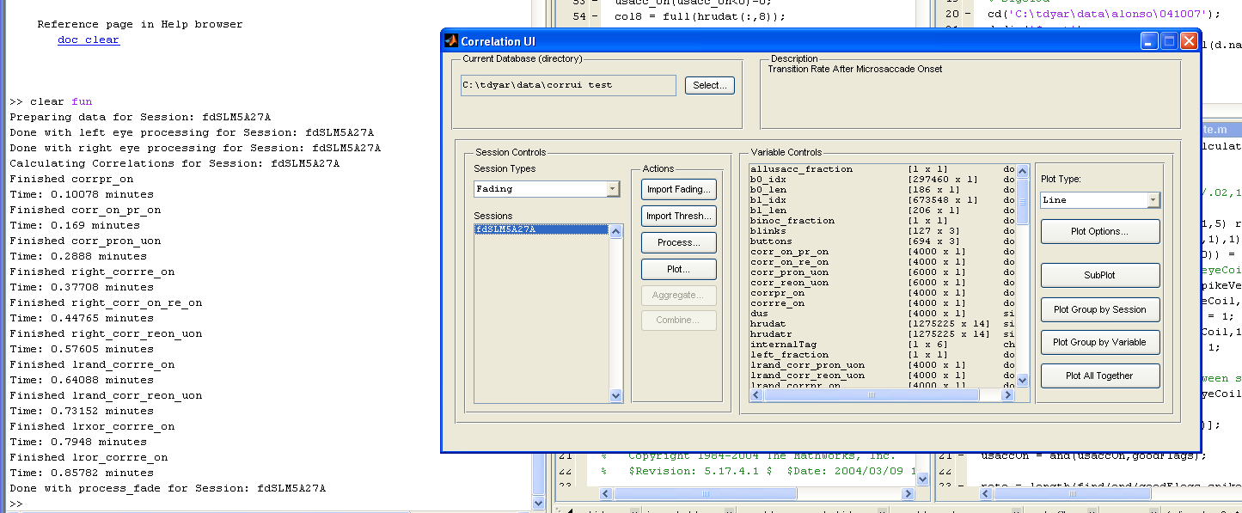
Figure 9 GUI after processing is finished. More variables (on right) are now associated with this session.

Plotting Session Data (“canned” plots)
Clicking the “Plot…” button brings up a dialog in which various types of pre-formatted plots can be generated, shown in Figure 10. Again this list of possible plots will vary depending on the type of session. Some of them are common to all the experiments and some of them are specific.
In the next figure
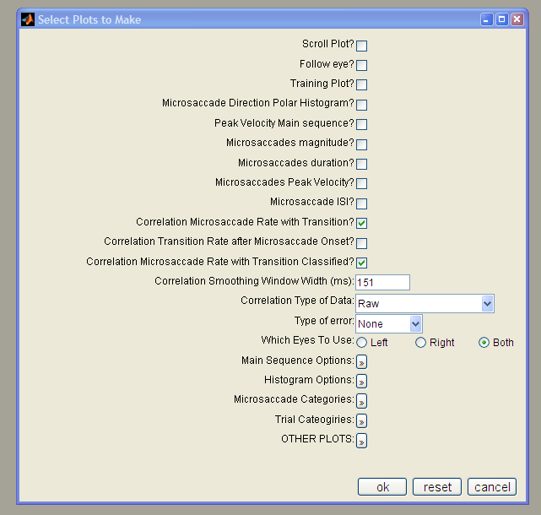
Figure 10 Select Plots to Make dialog for generating pre-formatted plots of microsaccade sessions for a Fading experiment

- “Scroll Plot”: shows the raw x- and y-data from the eyelink system, as well as the magnitude of current microsaccade, presence of microsaccades, blinks and button presses reporting subject’s perception of the stimulus
- “Microsaccade Direction Polar Histogram”: Plots a polar histogram of the directions of the microsaccades
- “Peak Velocity Main sequence”: Scatter plot of microsaccade magnitude vs. peak velocity and linear fit with error.
- “Microsaccade magnitude”: histogram of microsaccade magnitude distribution
- “Correlation Microsaccade Probability with Transition”: Plot correlation curves for transition to visibility and transition to invisibility, with average probability over entire session as a baseline
- …
- “Correlation Smoothing Window Width”: If not 0, Savitsky-Golay filter of specified width is applied to data before plotting
- “Type Of Data”: Select how do you want to see the data. Just the raw data, the percent deviation from the mean or the Z-score.
- “Which Eyes To Use”: Choose “Left, Right or Both” eye’s data. Both is average of left and right.

Click OK, and the chosen plots will be generated for each of the selected sessions, with a waitbar indicating progress. Some examples are shown in Figures 11 and 12.

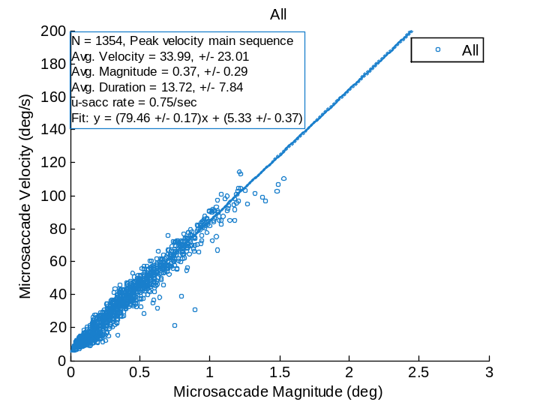
Figure 11 Example of "Peak velocity Main Sequence " plot
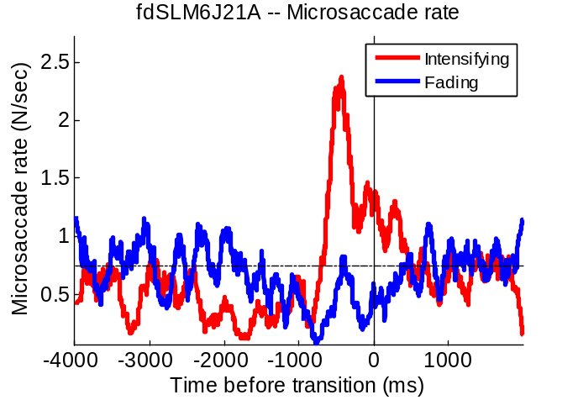
Figure 12 Example of "Microsaccade Rate before Transition" plot

Advanced plot options
- Correlation smoothing window with (ms). In the case of the correlation plots the data is smoothed using a savgolay filter using this parameter as window size.
- Correlation type of Data. Allows changing the scale of the plot. It can be:
  - Raw data
  - Percentage increase over baseline
  - Z-scores. Data is presented in terms of standard deviations from baseline
  - Percentage increase pre-smoothed. Usually data in the correlations is very noise and errobars for the raw data are big. If the data is smoothed before calculating the percent increase and the errorbars those will be smaller.
  - Raw-pre smoothed. More Realistic errobars
- Main sequence options. Options about main sequence formatting.
  - Type of points. Microsaccades are represented with dots, circles or the plot is made using a colormap instead of a scatter plot.
  - Axes. Linear or Log
  - Minimum X, Maximum X, Minimim Y, Maximum Y. Limits of the axes in the plot
  - Number of colormap bins. In the case of a colormap how mani pixels per axis the plot has.
- Histogram options. Options about main sequence formatting.
  - Y axis. Scale of the vertical axis
    - Number. The value of the histogram is just the number of elements that fall in each bin.
    - Percentage. The percent of elements that fall in the bin.
    - Rate. The number of elements that fall in the bin divided by the total time of valid data acquisition.
    - Percentmax. Result of using the number histogram and dividing by the maximum bin.
  - X axis. Linear or log
  - Use lines. By default histograms are plot with bars, if this option is check lines will be used instead. This is useful when plotting multiple lines in the same graph.
  - Manual bin range. Usually each plot will have a convenient range and number of bins. However that can be override with this option.
  - Minimum, Maximum, Number of Bins.
  - Fitting. A number of fitting of the data can be made. The fitting will be plot with a dashed line.
- Microsaccade categories. Plots can have multiple lines for multiple types of microsaccades. For instance, horizontal, vertical, binocular, monocular, etc …
- Trial categories. In the case of experiments with different types of trials. Diferent plots for each type of trial selected will be plotted.
- Other plots. Another plots not used so often.

Aggregate Sessions
An aggregate session is here defined as the statistical combination of 2 or more sessions. This encompasses both the mean across both left and right eyes, and the standard error across subjects, where each session is considered a separate subject (see “Combine Sessions”, below). An aggregate is created by selecting 2 or more sessions and then clicking the “Aggregate…” button. A dialog will appear where you select the name of the new session. Clicking “OK” will start the averaging process, with status displayed in the command window. Once an aggregate is defined, it is classified as a “Fading Average” session type, and can be viewed and manipulated in the Sessions list after selecting “Fading Average” in the “Session Types” drop-down box, shown in Figure 14.

When plotting aggregate sessions (“Plot…”), some additional options are available that add the error bars to the line plots.

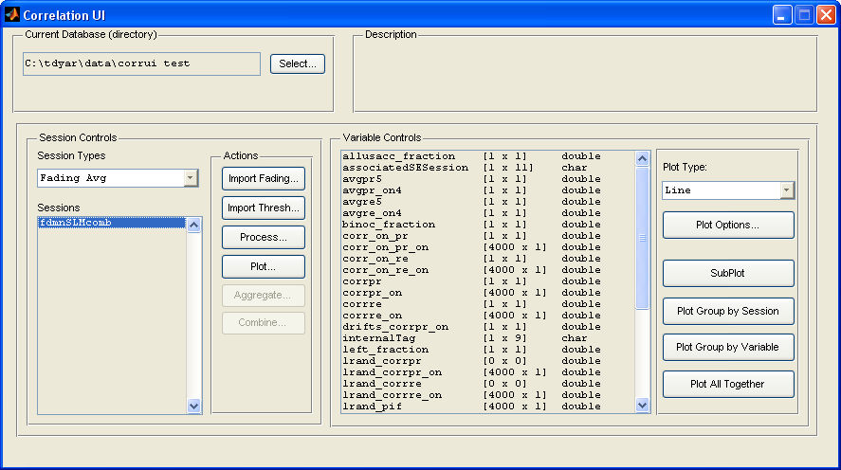
Figure 13 Aggregate sessions are in the Sessions list when "Fading Avg" is selected as the session type.

Plotting Session Variables
On the far right side of the main GUI window are buttons that generate plots of the variables selected in the “Variable Controls” section. There are many options to generate Line or Histogram plots (currently, more types may be added). Clicking “Plot Options…” brings up the dialog shown in Figures 15 through 17. The following options are provided:
- “Common X/Y Scale”: If more than 1 axis is generated, this option allows you to keep the X/Y saxis identically scaled for all axes
- “Smoothing Window Width”: Width of window for Savitsky-Golay smoothing
- “Number Histogram Bins”: number of bins in which to split data for histogram plots
- “Minimum/Maximum Bin”: Filter the data to only plot certain ranges of data – helps to hide small bins with outlier values
- “Concatenate Histogram Data”: Put data from several sessions into one big set, so histograms can be produced over a population of sessions. NOTE: Only implemented for some plots (TODO: specify which plots)

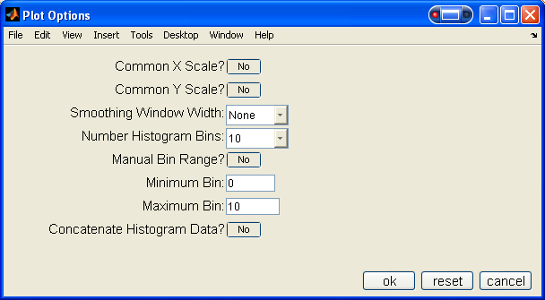
Figure 14 Variable plot options

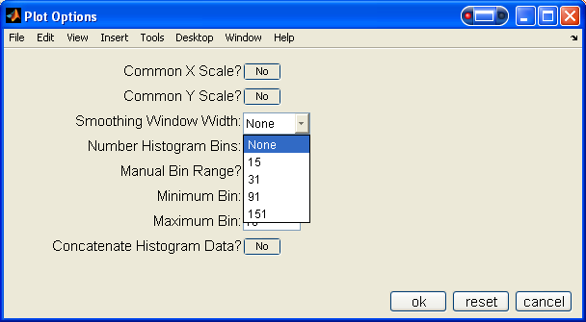
Figure 15 Smoothing Window Width option

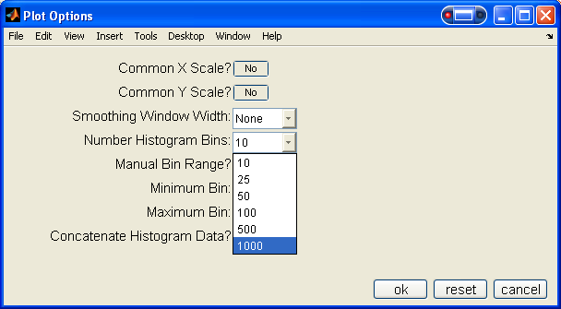
Figure 16 Bins option

Once the plot type and options are specified, clicking one of the plot buttons will generate the plot. The following groupings are currently implemented, and some example output is shown in the Figures 18 through 21.

- “SubPlot”: Plot each variable into its own axis. Sessions are in columns, variables in rows.
- “Plot Group by Session”: Plot variables from each session together, a different axis for each session
- “Plot Group by Variable”: Plot variables from different sessions together, a different axis for each variable
- “Plot All Together”: Plot all selected variables from all selected sessions in one axis.
NOTE: if one of the variables selected to plot is a scalar the plot will have a horizontal line with the value of the variable and covering the whole width of the plot.
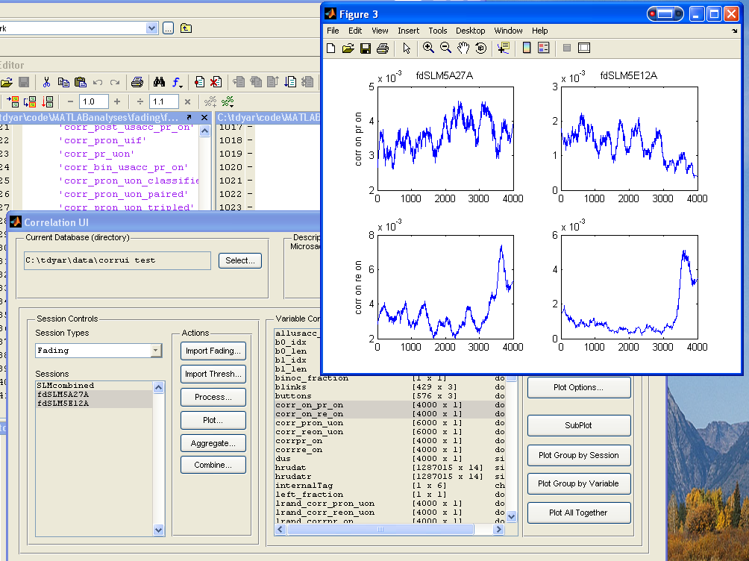
Figure 17 SubPlot line plot example

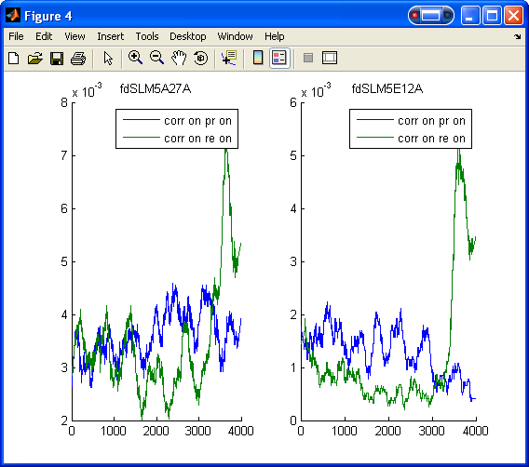
Figure 18 Group by Session example

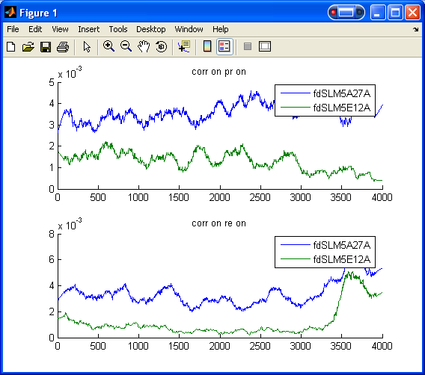
Figure 19 Group by Variable example

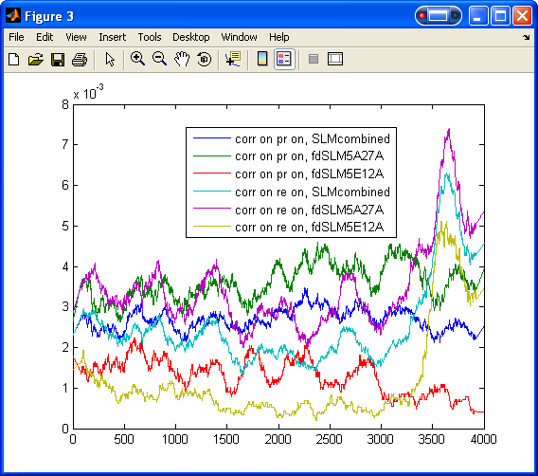
Figure 20 Plot All Together example

